LEGAL EASE
AI-Powered Legal Document Generator
Project Documentation

Prepared for the Legal Ease – AI-Powered Legal Document Generator project

CERTIFICATE
This is to certify that the project entitled “Legal Ease – AI-Powered Legal Document Generator” has been successfully developed as a five-member group project. The project demonstrates the integration of a Python, Streamlit, AI/NLP, document processing, and structured legal-document generation.
Project Type: AI-Based Application
Team Size: 5
Guide: ______________________________________
Team Leader: Srinithi S
Team Member: Janani S
Team Member: Powernika S
Team Member: Parkavi S
Team Member: Sathya shree S

DECLARATION
We hereby declare that the project “Legal Ease – AI-Powered Legal Document Generator” has been developed by our five-member team as an academic software project. The application combines AI-assisted document generation, user input processing, validation, and document formatting to demonstrate a practical real-world use case.
Project Type: AI-Based Application
Team Size: 5
Guide: ______________________________________
Team Leader: Srinithi S
Team Member: Janani S
Team Member: Powernika S
Team Member: Parkavi S
Team Member: Sathya shree S

LEGAL EASE
AI-Powered Legal Document Generator
PROJECT DOCUMENTATION

Project Title | Legal Ease – AI-Powered Legal Document Generator
Technology | Python, Streamlit, AI/NLP, Document Processing
Project Type | AI-Based Application
Purpose | Generate structured first drafts of legal documents
Note: This project is intended for document drafting assistance. AI-generated content should be reviewed by a qualified legal professional when appropriate.

1. Introduction
Legal Ease is an AI-powered legal document generator that helps users prepare structured first drafts of common legal documents. Instead of starting from a blank page, users provide basic information through a simple interface. The system processes the information, selects a suitable structure, and generates a readable draft.

Need for the System
- Manual legal document preparation can take considerable time.
- Users may not know the correct structure or terminology.
- Repeated document preparation can involve repetitive work.
- A digital assistant can organize information quickly.
- AI can help create a first draft that can then be reviewed and edited.

Scope
The project focuses on generating draft documents such as rental agreements, non-disclosure agreements, and employment agreements. The system can later be expanded to support additional document types and languages.

2. Problem Statement
Preparing legal documents manually is often difficult for people who are unfamiliar with legal formats. Important information may be missed, documents may have inconsistent formatting, and preparing a first draft can be time-consuming. Users need a simple system that collects the required details and converts them into a structured draft.

Existing Problems
- Time-consuming manual drafting.
- Difficulty in maintaining consistent formatting.
- Users may miss important fields or clauses.
- Repeated work for similar documents.
- Limited accessibility for users with little legal-document experience.

Proposed Solution
Legal Ease provides a guided interface, input validation, AI-assisted drafting, document preview, and download support. The application is designed as a drafting assistant rather than a replacement for legal professionals.

3. Objectives
- Develop a simple AI-powered legal document generation application.
- Collect required information through an easy user interface.
- Validate important user inputs before generating a document.
- Generate a structured first draft from the supplied information.
- Reduce repetitive manual drafting work.
- Provide a preview before the user saves the document.
- Support multiple document categories.
- Make the system easy to extend with new templates and clauses.

Expected Benefits
- Faster initial document preparation.
- Better organization of user-provided information.
- Consistent document structure.
- Easy editing and review.
- Potential support for multiple languages and document formats.

4. System Workflow
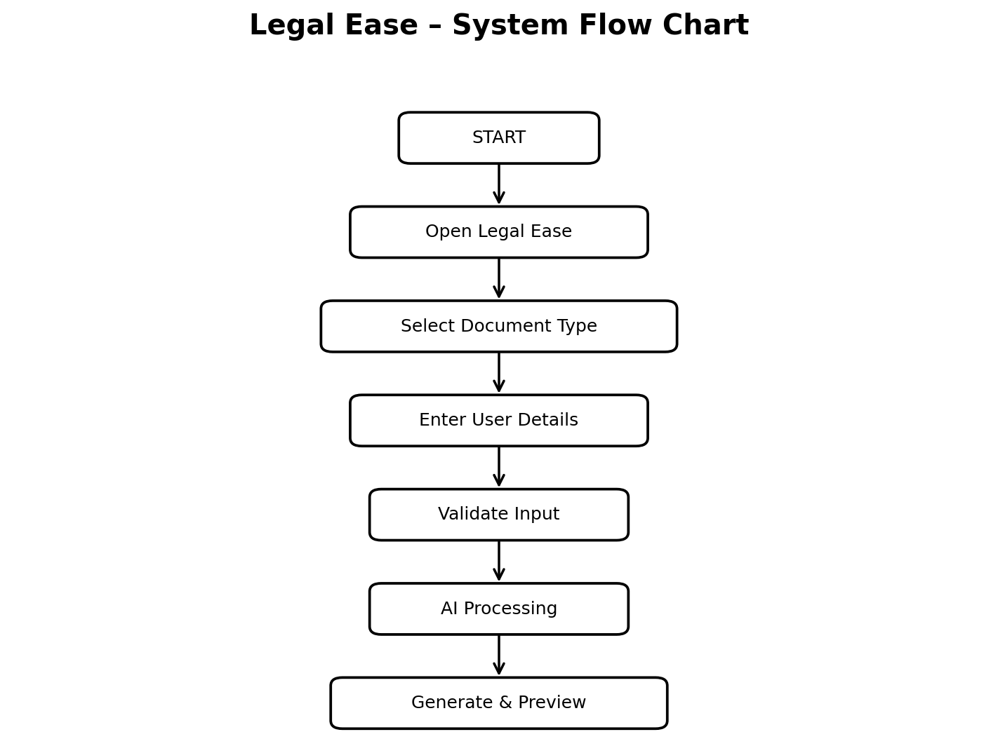
Workflow explanation: The user starts the application, selects a document type, enters the required information, and submits the form. The system validates the data, processes it through the AI/document-generation layer, creates a draft, and displays the result for review.

5. System Architecture
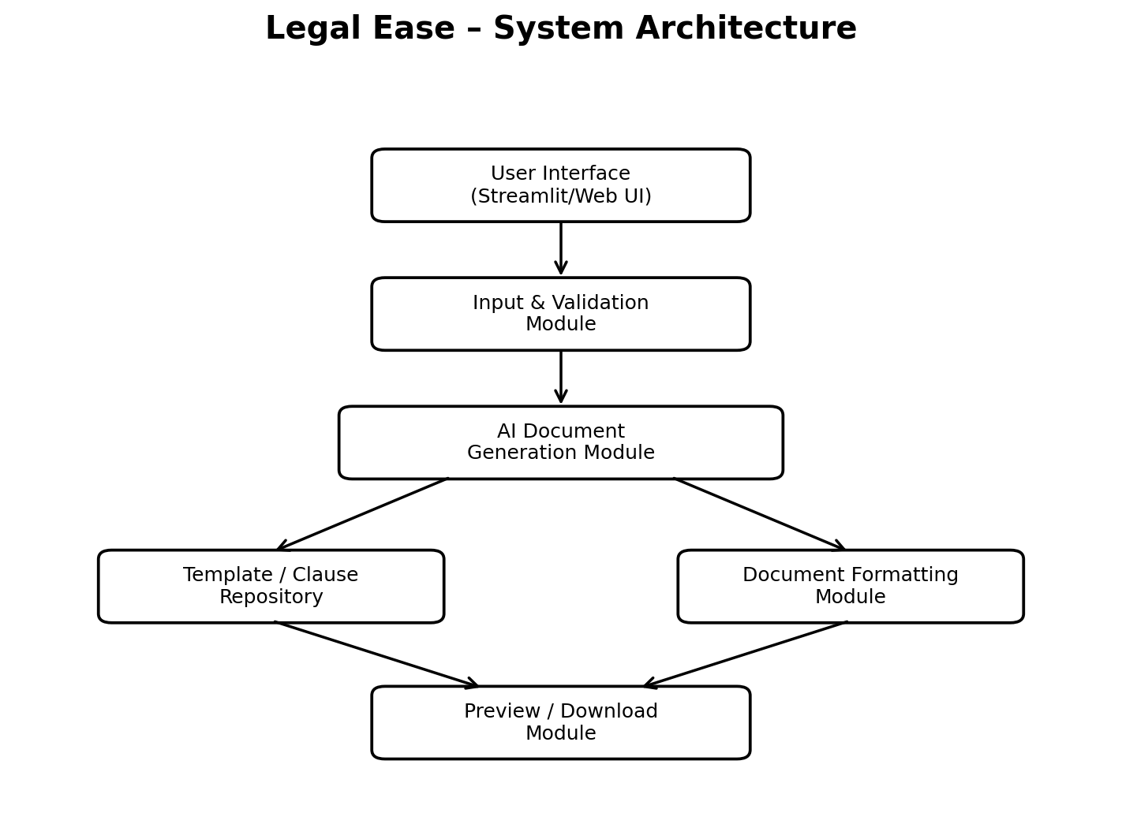
The architecture separates the user interface, validation, AI processing, document templates, formatting, and output functions. This modular structure makes the project easier to test and maintain.

6. Modules
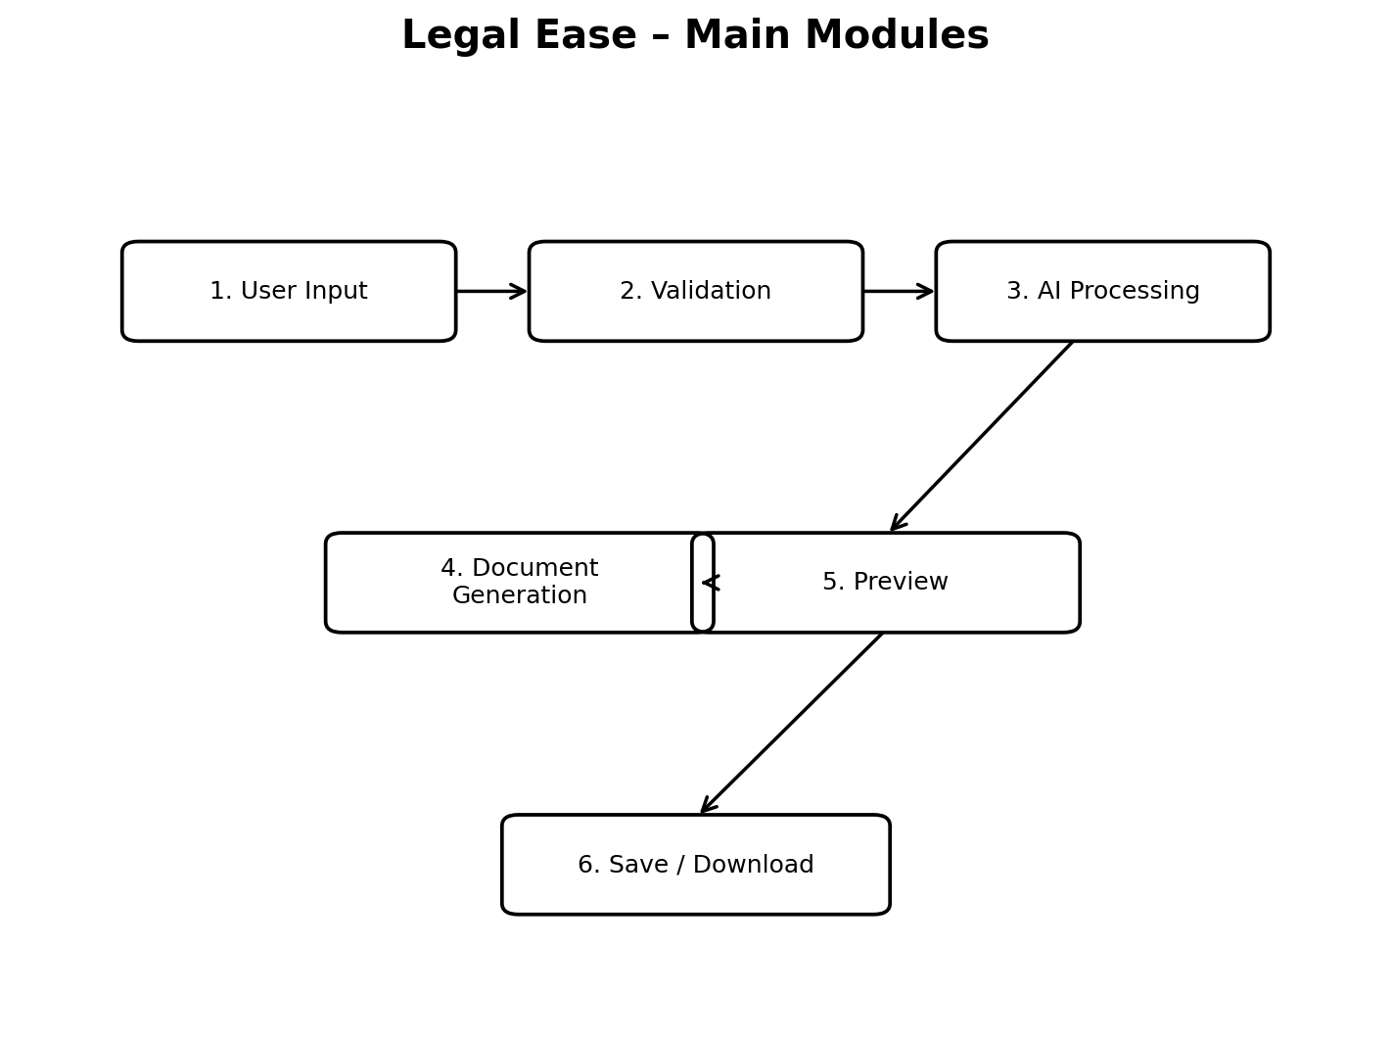

Module Description
- User Input Module – collects document type, names, dates, purpose, and terms.
- Validation Module – checks whether required information has been entered.
- AI Processing Module – converts the user information into a structured draft.
- Document Generation Module – combines the content into the selected document format.
- Preview Module – displays the generated draft for checking.
- Save/Download Module – provides the final draft in a usable format.

7. Example

Example: Rental Agreement
User Input:
Document Type | Rental Agreement
Landlord | Arun Kumar
Tenant | Priya Devi
Property | Residential House, Salem
Rent | ₹12,000 per month
Period | 11 months

Generated Draft – Sample
RENTAL AGREEMENT
This is a sample AI-assisted draft prepared from the information supplied by the user. It identifies the parties, property, rental amount, agreement period, and other selected terms. The user can review and edit the draft before saving it.
Important: The sample is illustrative only and is not a substitute for legal advice.

8. Coding – Prototype
The following simple Python/Streamlit code demonstrates the main project concept.
import streamlit as st
st.title("Legal Ease - AI Legal Document Generator")
doc_type = st.selectbox(
"Select Document Type",
["Rental Agreement", "NDA", "Employment Agreement"]
)
name1 = st.text_input("First Party Name")
name2 = st.text_input("Second Party Name")
purpose = st.text_area("Purpose / Important Terms")
if st.button("Generate Document"):
if name1 and name2 and purpose:
document = f"""
LEGAL DOCUMENT
Document Type: {doc_type}
First Party: {name1}
Second Party: {name2}
Purpose / Terms:
{purpose}
AI-assisted draft - review before use.
"""
st.subheader("Generated Document")
st.text_area("Preview", document, height=300)
else:
st.warning("Please enter all required details.")

9. Coding Explanation
- import streamlit as st imports the Streamlit library used to build the web interface.
- st.title() displays the application title.
- st.selectbox() allows the user to select a document type.
- st.text_input() collects names and other short details.
- st.text_area() collects longer terms or descriptions.
- The Generate Document button starts the generation process.
- The if condition checks whether required fields contain data.
- An f-string is used to place the user information into the draft.
- st.text_area() displays the generated document for review.
- st.warning() informs the user when required information is missing.

Possible AI Integration
In a full implementation, the document-generation function can be connected to an approved AI language model or an organization's secure AI service. The application should validate outputs, protect personal data, and provide clear disclaimers before users rely on generated content.

10. Outputs

Input Screen – Expected Fields
- Document type
- First party name
- Second party name
- Date and duration
- Purpose
- Important terms or clauses

Sample Output
GENERATED LEGAL DOCUMENT
Document Type: Rental Agreement
First Party: Arun Kumar
Second Party: Priya Devi
Property: Residential House, Salem
Rent: ₹12,000 per month
Period: 11 months
Status: Draft generated successfully.
AI-assisted draft – review carefully before use.

Output Features
- Readable document structure.
- User-specific information.
- Preview before download.
- Editing before final use.
- Clear indication that the content is an AI-assisted draft.

11. Software and Tools Used
Tool / Technology | Purpose
Python | Application development
Streamlit | Web-based user interface
AI / NLP service | Assisted document generation
Document templates | Consistent document structure
DOCX / PDF libraries | Document export
Database (optional) | Secure storage of templates and history

System Requirements
- Computer or mobile device with a supported browser.
- Python environment for development.
- Internet connection when a cloud AI/API service is used.
- Secure storage if user documents are saved.

12. Advantages and Limitations

Advantages
- Simple and user-friendly interface.
- Reduces repetitive initial drafting work.
- Provides a consistent document structure.
- Can support multiple document types.
- Can be extended with multilingual support.
- Preview helps users check the draft before saving.

Limitations
- AI-generated content can contain errors.
- Complex legal matters may require professional legal advice.
- The quality depends on the input information and AI service.
- Privacy and security must be carefully designed.
- Legal requirements can differ by jurisdiction and may change over time.

13. Future Scope
- Add more legal document templates.
- Support Tamil and other regional languages.
- Provide DOCX and PDF export.
- Add secure login and document history.
- Add clause suggestions and missing-information alerts.
- Provide document comparison and version history.
- Improve validation using structured legal forms.
- Add role-based access for organizations.
- Connect users with qualified legal professionals where appropriate.
- Add stronger privacy, encryption, and secure storage.
- Support organization-specific templates.
- Add voice-based input for accessibility.
- Provide a dashboard for managing generated documents.
- Improve AI output evaluation and human review workflows.

Safety and Legal Review
Future versions should include strong privacy controls and clear notices that generated text is a draft. For important legal matters, the final document should be reviewed by an appropriately qualified professional.

14. Result and Conclusion
The Legal Ease project demonstrates how an AI-assisted application can simplify the preparation of structured first drafts of legal documents. The system accepts user details, validates the input, processes the information, generates a draft, and provides a preview for review. Its modular architecture makes it possible to add new document types, templates, languages, and output formats.

Result
A working prototype concept was designed for collecting legal-document information and producing a structured draft. The project meets its main objective of making initial document preparation simpler and more organized.

Conclusion
Legal Ease can be developed into a useful document-drafting assistant by combining a simple interface, document templates, AI processing, and secure document management. The system should always be used responsibly, with appropriate review for legal accuracy and compliance with the laws applicable to the user's situation.

References
- Python documentation and standard library references.
- Streamlit documentation.
- General principles of document automation and natural language processing.
- Applicable legal drafting guidance and professional review.

